Lecture 8

9/21/2020

CPSC 131

1. Pointers and lists  
   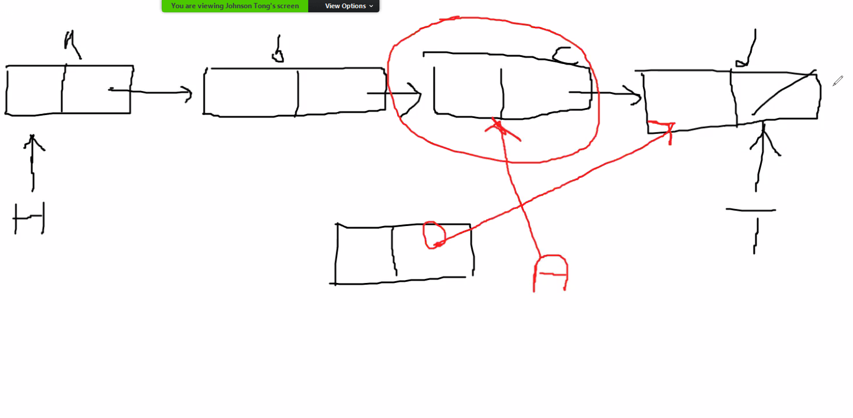
   1. As shown through this diagram, our list needs to increase as each new element is inserted. Pointers are involved as A’s pointer is what will point to the END/TAIL node instead of C’s.
2. The Code
   1. SLINKEDLIST: INSERT  
      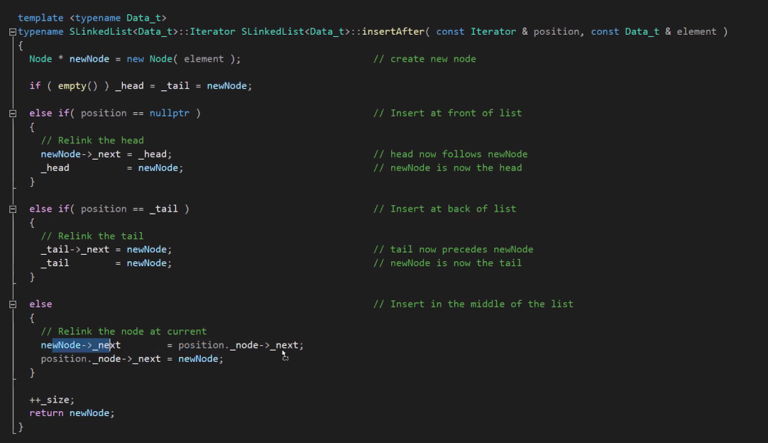
      1. When you insert in the middle of the list
   2. Iterators  
      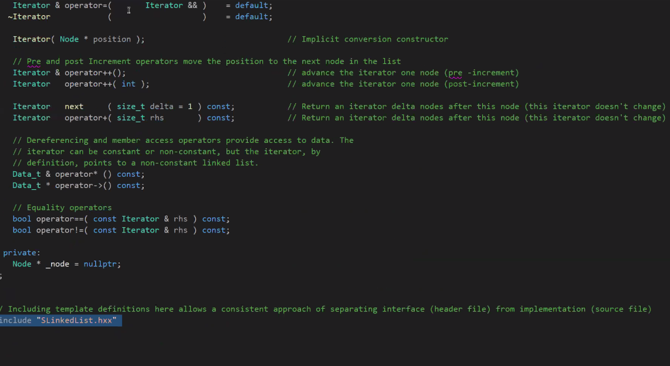
   3. insertAfter: Adjusting the head and/or tail  
      